**PRACTICAL**

Configure DHCP Server, Configure DHCP (Dynamic Host Configuration Protocol) Server.

Install the dhcp server package

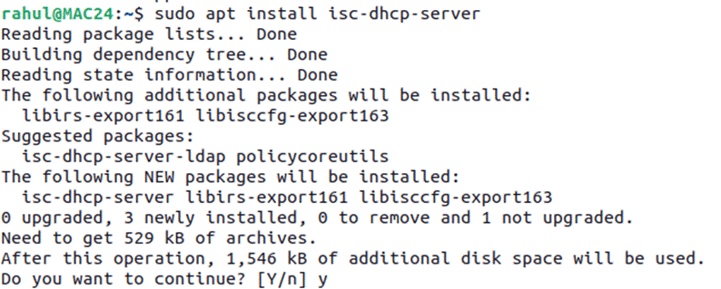

Configure the dhcp server by opening the “dhcpd.conf” file and configure it



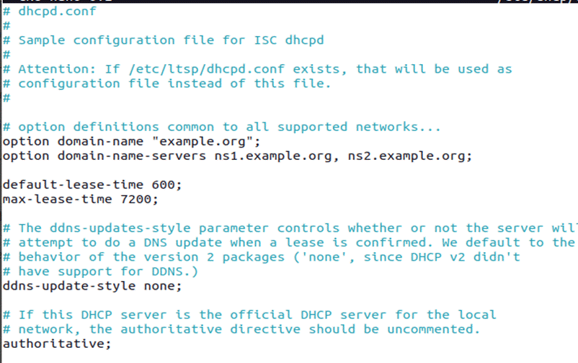

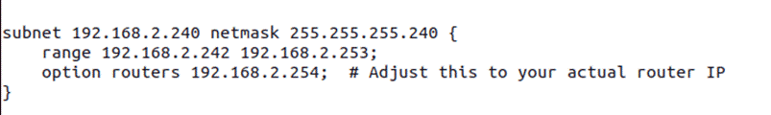

Give the static ip to the Machine

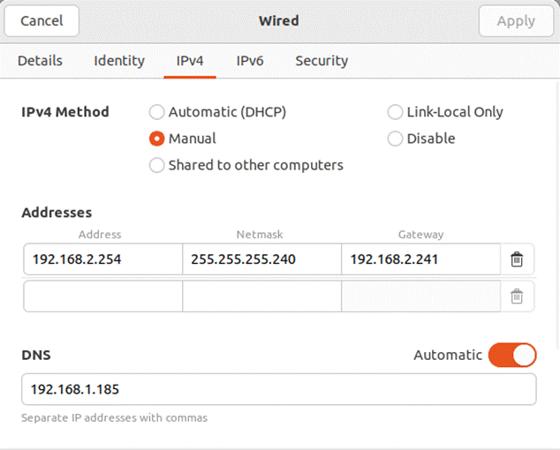

Check the interface name

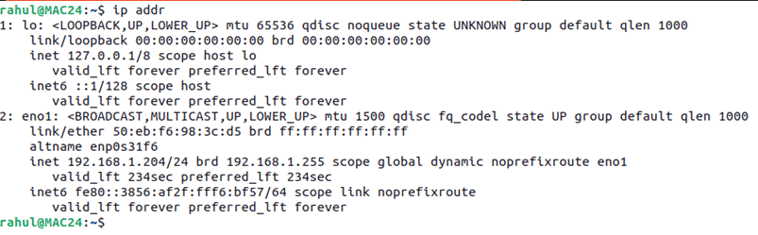

Open the below path file and give the interface name



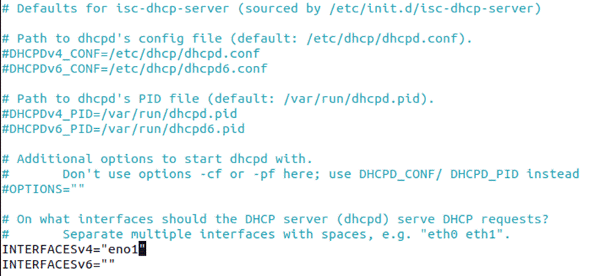

Start the dhcp server



Enable the  dhcp server

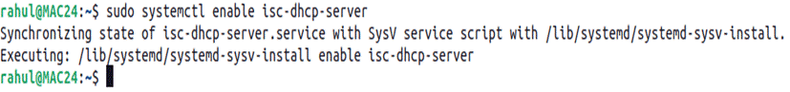

Know check the status of dhcp server

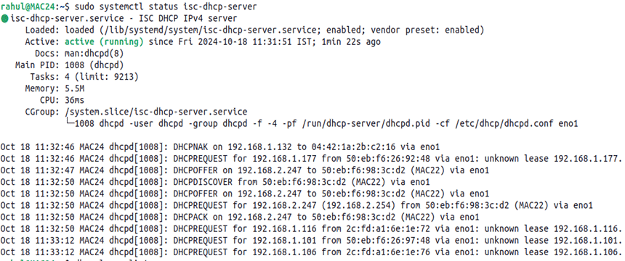

Check the dhcp give ip machines

